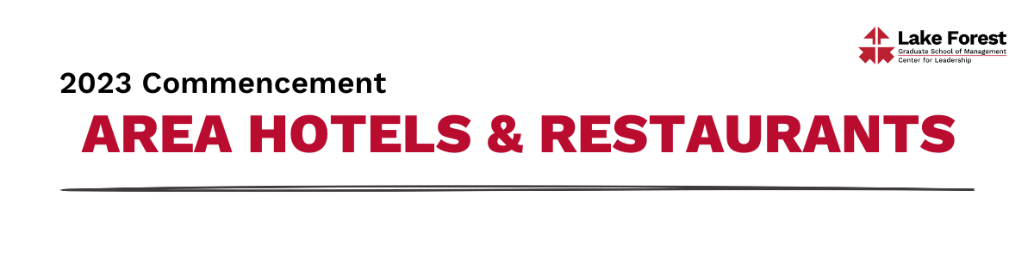
HOTELS – Lake Forest/Mettawa

Deer Path Inn

255 E. Illinois Road

Lake Forest, IL 60045

847.234.2280

The Forester - A Hyatt Place Hotel
200 North Field Drive
Lake Forest, IL 60045
847-582-6400

Residence Inn Marriott Lake Forest Mettawa

26325 N Riverwoods Blvd

Mettawa, IL 60045
847-615-2701

Hilton Garden Inn Lake Forest Mettawa

26225 N Riverwoods Blvd

Mettawa, IL 60045
847-735-8639

RESTAURANTS – Lake Bluff
Inovasi
American Bistro & Bar
28 E Center Drive
Lake Bluff, IL 60044
847-295-1000

Maevery Public House
Upscale American food
20 E Scranton Avenue
Lake Bluff, IL
847-604-3952

Silo Restaurant
Casual American/Pizza
625 Rockland Road
Lake Bluff, IL 60044
https://silopizza.com/

RESTAURANTS – Lake Forest

Authentico

Contemporary Mexican

770 N. Western Ave.

Lake Forest, IL 60045

847-295-3500

The English Room at Deer Path Inn

Upscale Contemporary American

255 East Illinois Rd

Lake Forest, IL 60045

847.234.2280

Francesca’s Intimo
Italian – Pasta, Pizza & Wine
295 E Illinois Rd
Lake Forest, IL 60045
847.735.9235

Le Colonial

Upscale Vietnamese

655 Forest Avenue

Lake Forest, IL 60045

847-474-1500

Oaken Bistro + Bar @The Forester Hotel

Bistro – burgers & salads

200 North Field Drive

Lake Forest, IL 60045
847-582-6410

Sophia Steak
Steakhouse
181 E. Laurel Ave.
Lake Forest, IL 60045
847-920-7002

Sushi Kushi Toyo
Japanese
825 Waukegan Road
Lake Forest, IL 60045
847-234-9950

